|  |  |
| --- | --- |
| Krishna Kanth B | invoice |
| Old: 24/1, New 47  Govindappa Naicken Street,  George Town, Chennai  India 600001 | **INVOICE** #002  **DATE 26/Sep/2024** |
| TO  Katy Ward  Alloy.dev  3131 Western Ave, Site 527,  Seattle, Washington, zip code 98121  United States  accounting@amplenote.com |  |

|  |  |  |
| --- | --- | --- |
| Description | | Amount |
| Notes Reviewer Plugin | | $750/- |
|  | |  |
|  | |  |
|  | |  |
| **Total** | | $750/- |
|  | (Seven Hundred and fifty Dollars Only/-) | | |
|  | |  |

**For Queries:**

Krishna Kanth B,

[kkvitbiotech@gmail.com](mailto:kkvitbiotech@gmail.com),

(+91)7667360114

**Payment Details:**

Email: [krishnakanthb13@gmail.com](mailto:krishnakanthb13@gmail.com)

Paypal.me link: <https://www.paypal.com/paypalme/krishnakanthb13?>

**(P.T.O.) - additional details**

**Requirements:**

<https://www.amplenote.com/bounty_plugins>

<https://amplenoteplugins.featureupvote.com/suggestions/558871/review-notes-plugin>

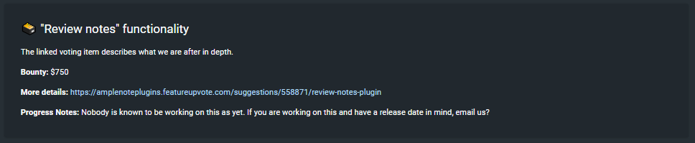

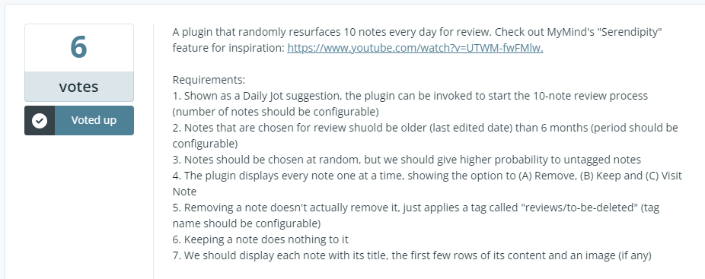

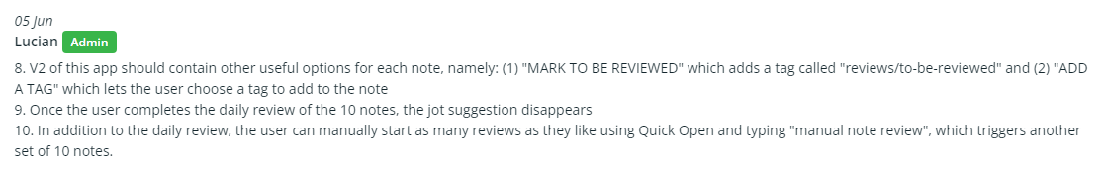

**Published Plugin:**

<https://www.amplenote.com/plugins/8KDWax9RAQ9g41HgnR3f7aRK>

